Final Project
I. Introduction & Background
I work at a company that provides accounts payable solutions for small to medium sized businesses. Although most of the company is focused on developing and selling a software solution, they also provide business process outsourcing services. The scan department provides one these services, as they are responsible for processing these invoices from physical/electronic mail and doing some data entry before forwarding the invoices to a customer’s AP team. These invoices are typically grouped into batches based on the customer and the time the invoices were received. Because this process can not be fully automated, there is some information that scan operators are required to manually keep track of:
- The time a document was received
- The time a document was released to the customer
- The customer name
- The number of invoices per batch
Time information is important because they are used to determine whether the team meets the 48-hour turnaround time as promised in the customer’s contract, and invoice counts are important to track for billing purposes.
Unfortunately, the current method used to track batch information has many shortcomings. The operators are first required to keep handwritten logs and then to transfer that information to excel spreadsheets that are separated by customer and month. The spreadsheet contains formulas that calculate column totals on the time and count, which the scan team uses to manually verify against a report hosted on the application server that all invoices are released to. While there are many ways this process can be improved, I wanted to focus on the dependency on excel, which has several issues that make it poorly suited for holding this data:
- It does not support concurrent access – this is problematic whenever we have more than 1 operator working on a customer.
- Many operators find it difficult to add rows to the spreadsheet without breaking the formula calculations, leading to errors in the daily counts / times.
- Backups are nonexistent whenever the spreadsheet gets corrupted
II. Proposed Solution
As a solution to these problems, I designed a web application that allows users to enter and store this batch information.
- The concurrency issue is solved because web apps support multiple-user access, while the database itself keeps logs that can keep all concurrent transactions isolated.
- All calculations are done in the Python application, and adding more records is as trivial as filling out a form
- Table backups can be easily made, and logging makes it easier to recover lost data.
- The functionality of the web application can be easily extended because all information is kept in a database, and they can easily be queried and used to make reports.
III. Frameworks and Technologies
The application was developed using Python and Flask, and it uses MySQL as the database. I also used the Flask-SQLAlchemy extension to handle the database connection and manage all the data definitions. I have never used a web framework before, so Flask was a natural choice due to its simplicity and ease-of-use. It took less than three hours before I finished setting it up and creating a table with basic CRUD functionality. Using Bootstrap classes also enabled me to easily achieve a clean and responsive UI. My workflow usually started with me creating some simple forms and tables with HTML, connecting those elements to Flask via Jinja templates, and then writing Python code that translates the POST / GET requests into specific database operations.
III. Schema Diagram
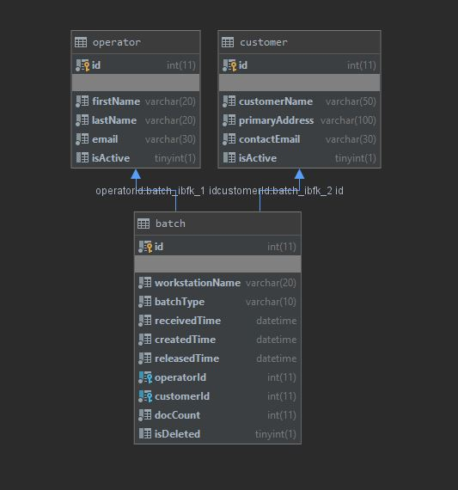
As shown in the schema diagram, most of the functionality is based around the ‘batch’ table, which holds the pertinent information used by the scan department.
IV. Results
The resulting web application has most of its functionality broken up into separate web pages / routes.
- Home Page
The landing page just contains table that will display the name of any operator who released a batch today. This was done only to demonstrate the use of a nested query.
- Operators, Customers, and Batches
These pages are dedicated to displaying table information as-is, and users are given the options to add, edit, and delete records. Because there are foreign key constraints, trying to delete any user or customer when they are referenced by any batches will return an error from the database. The “Batch” page also contain a filter, so you find batches fulfilling a specific criterion.
- Reports by Customer & Reports by Operator
The “Reports by Customer” page contains two tables. One table displays a daily document count separated by customer, and another table displays the month document count. There are filters on the page to change the month or the date displayed by the table. “Report by Operator” returns the same information, except these totals are separated according to the operator who processed the batch.
- SLA
This page displays a list of all batches and the hours between when the batch was received and released. Any batch exceeding 48 hours is highlighted in red.
- Export
This page contains a link that outputs the information from the Batch table into a downloadable csv file.
It is important to note that certain fields such as customer ID and Operator ID are not returned, instead the actual customer or operator name is returned in those columns. This is also the case when trying to add records on the “Batches” page; instead of prompting the user for an Operator ID or a Customer ID. I decided to display the actual name because id numbers are not necessarily useful on their own, and it reduces the need to reference between the Batch and Operator table.
V. Final Thoughts
I am happy with what I have achieved with this project. It was a lot of fun to build a full-fledged web application from scratch, and I picked up some useful skills along the way. I regret not designing a more complicated schema since it was difficult for me to write a decent subquery or query using joins, but I believe this project has a lot of potential and usefulness. I hope work on this more during the summer so I can present it to the scan department for future use.

